

-------------------------------------

Behavioral Health &

Criminal Justice VIRTUAL Conference

-------------------------------------

Tuesday, May 4, 2021 &

**9:00a – 12:30p**

Wednesday, May 5, 2021

**9:00a – 12:30p**

A Two-Day LIVE ONLINE Event!



Behavioral Research & Training Institute

Technical Assistance Center



That’s a Wrap

*Advancing recovery and reducing recidivism using wraparound services*

To register for this free event click [**HERE**](https://rutgers.cloud-cme.com/wrap2021)

**Featured Speakers**:



**Nicholas Crapser**, MA LPC, LMHC, CADC-III, SUDP, NCC, MAC, CSC, ACS

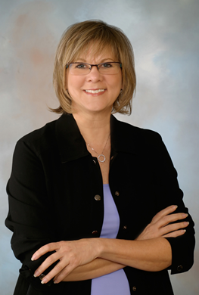

**Nancy Wolff**, PhD



**Douglas Evans**, PhD

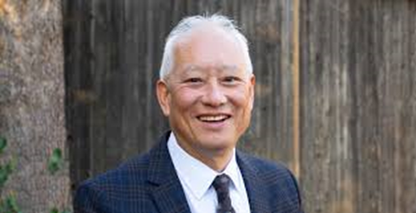

**David Mee-Lee**, MD

Please contact Tameka Chatman at 732-235-9279

or [tameka.chatman@rutgers.edu](mailto:tameka.chatman@rutgers.edu) for additional information

***We gratefully acknowledge the sponsorship of this event by the New Jersey Division of Mental Health & Addiction Services***

**Behavioral Health &

Criminal Justice Conference

That’s a Wrap

*Advancing recovery and reducing recidivism using wraparound services*

|  |  |  |
| --- | --- | --- |
|  | ***DAY ONE - Tuesday, May 4, 2021*** |  |
| 8:45 AM - 9:00 AM | Check-In |  |
| 9:00 AM – 10:40 AM | What Works with Individuals with Conviction Histories and Behavioral Health Diagnoses: Examining the Evidence, Best Practices, and Deficits | Nicholas Crapser, MA, LPC, LMHC, CADC-III, SUDP, NCC, MAC, CSC |
| 10:40 AM – 10:50 AM | Break |  |
| 10:50 AM – 12:30 PM | Doing Time or Doing Treatment? Working together to Engage  Participants in Collaborative Accountable Recovery | David Mee-Lee, MD |
|  | ***DAY TWO - Wednesday, May 5, 2021*** |  |
| 8:45 AM - 9:00 AM | Check-In |  |
| 9:00 AM – 10:40 AM | Beyond Belief – Understanding the effects of stigma and implicit bias on recovery and recidivism | Douglas Evans, PhD |
| 10:40 AM – 10:50 AM | Break |  |
| 10:50 AM – 12:30 PM | Through the Looking Glass: Applying a trauma-informed lens to your work with forensically-involved behavioral health consumers | Nancy Wolff, PhD |
|  | ***All Wrapped Up!***  – Thank you for attending! |  |

**Agenda**

**Target Audience:** Professional Counselors, Alcohol & Drug Counselors, Social Workers, Psychologists, Marriage & Family Therapists, Persons in Recovery, Criminal Justice System professionals.

**Program Goal:** To enhance person-centered care within the behavioral health system for forensically-involved consumers

and increase the use of evidence-based, best, and promising practices.

**Objectives**:

1. Discuss at least 2 strategies for enhancing person-centered care within behavioral health and criminal justice services.
2. Examine 3 or more policies, trends, enablers, and barriers pertaining to services that reduce incarceration and recidivism, facilitate re-entry, and promote recovery.
3. Describe at least 2 ways to engage mandated justice-involved consumers in behavioral health services.
4. Examine at least 3 ways to foster effective partnerships between treatment providers and justice teams.
5. Analyze at least 3 ways in which engagement and effective partnerships decrease risk of relapse, re-hospitalization and/or recidivism for justice-involved behavioral health consumers.
6. Assess at least 3 effects of stigma/bias on returning citizens’ emotional well-being/ mental health, potential for relapse and/or recidivism.
7. Analyze current practices/policies regarding trauma-informed care for behavioral health consumers with criminal justice involvement and discuss at least 2 ways to provide effective agency-wide trauma-informed services.



 Behavioral Health &**

**Criminal Justice Conference**

That’s a Wrap

*Advancing recovery and reducing recidivism using wraparound services*

**Additional Information**

* **Cancellation Policy:** If you have registered but cannot attend this program, please call so that we can offer your seat to

an individual on the waiting list. In case of inclement weather or other unforeseen circumstances, please call 732.235.9290 beginning at 8 a.m. on the scheduled training day for a recorded informational message about the status of the training.

* **Special Needs:** If you have a special needs (ADA) and wish to discuss possible provisions, please contact Technical Assistance Center at 732-235-9290.
* **Delivery Format:** Live Virtual Training Program

Registering for this activity in RBHS CloudCME.

1. Login: Click on registration link. You will be prompted to create an account if you are first time user. Please fill out all fields to complete profile and return to original link to complete registration. Rutgers employees and affiliates should use their single sign on account information.
2. Register: Click on ‘REGISTER’ – Your name and email will appear in red with the message ‘*If this is correct, click Continue to start your registration. If this is not you, please click 'Sign Out' in the site navigation above and login with your own account.*Your name and email will appear in red font**,** indicating that you are logged in.
3. **For this conference – the registration is complimentary.**

Promotion code message appears to all attendees even if there is no code. This does not stop the registration process**. Click on Blue CONTINUE button.**

1. Select registration type. Typically, there is only one option. (Ex: General Attendance; CE Certificate and Registration)
2. Survey: Select source of program registration information in checkbox.
3. To ensure payment and registration were completed please log into your RBHS CloudCME profile, select “MY CE’ Menu – go to registrations and receipts to confirm registration and payment completion.
4. Please fully complete your profile in RBHS CloudCME – Conference organizers will be mailing supporting materials to your address of record following the conference.

**FREE Professional Contact Hours Provided**

*Please note that participants may not be eligible for continuing education credits if they are not on time and present for the entire event on*

*BOTH DAYS. Partial credits will not be issued to participants arriving late or leaving early.*



In support of improving patient care, Rutgers Biomedical and Health Sciences is jointly accredited by the Accreditation Council for Continuing Medical Education (ACCME), the Accreditation Council for Pharmacy Education (ACPE), and the American Nurses Credentialing Center (ANCC), to provide continuing education for the healthcare team.

**Psychologists:** This course is approved for 7.0 CE Credits. Beginner level. Continuing Education (CE) Credits for Psychologists are provided through the co-sponsorship of the American Psychological Association (APA) Office of Continuing Education in Psychology (CEP). The APA CEP Office maintains responsibility for the content of the programs.

**Social Workers** (The New Jersey Board of Social Work Examiners): This program is approved for social work continuing education hours by Rutgers University Behavioral Health Care in accordance with New Jersey administrative code 13:44G-6.4 and recognized by The New Jersey Board of Social Work Examiners.  This program is approved for 7.0 continuing education hours and fulfills the NJ Social Work requirements for cultural and social competency education.

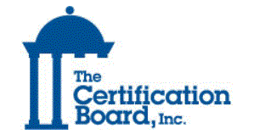

Continuing education content has been submitted for review to The Certification Board of NJ, INC. for the following disciplines: Certified Counselors, Certified Alcohol and Drug Counselors, Certified Recovery Support Practitioner and Marriage and Family Therapists.

For questions about the continuing educational content, please contact: For questions concerning behavioral health & social work contact hours, please contact Rutgers UBHC Center for Continuing Education at CCE@ubhc.rutgers.edu.